Week 1

**Installation and Abstract Writing**

1. Installation of Docker

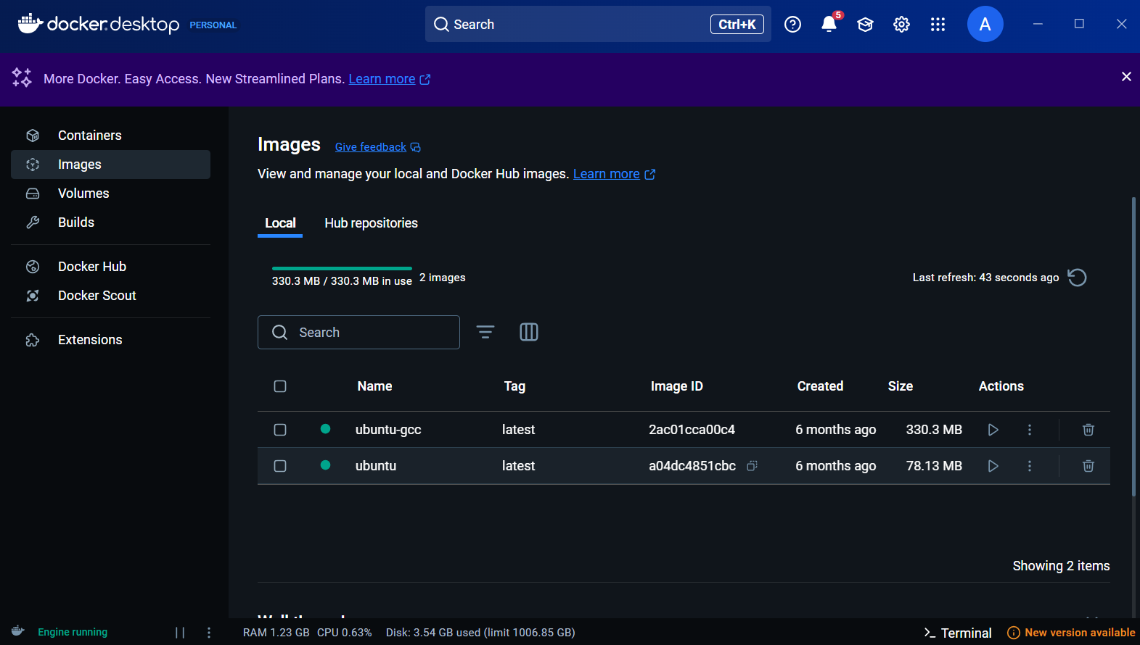

1. Installation of Star UML

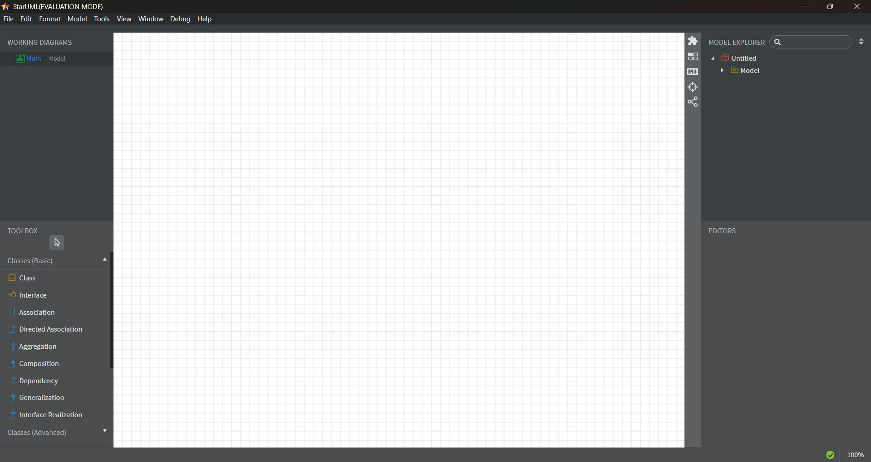

1. Git Bash

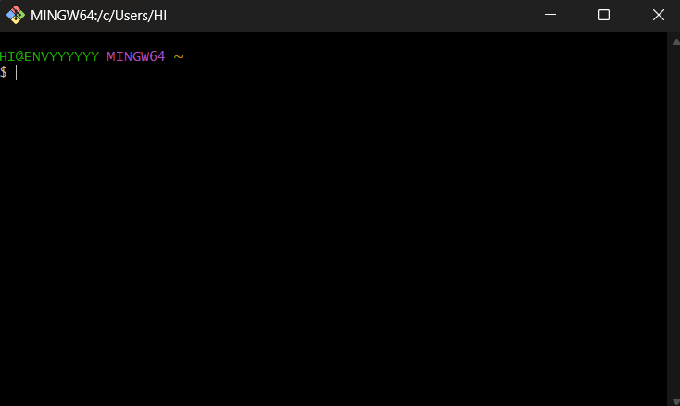

1. Docker Hub

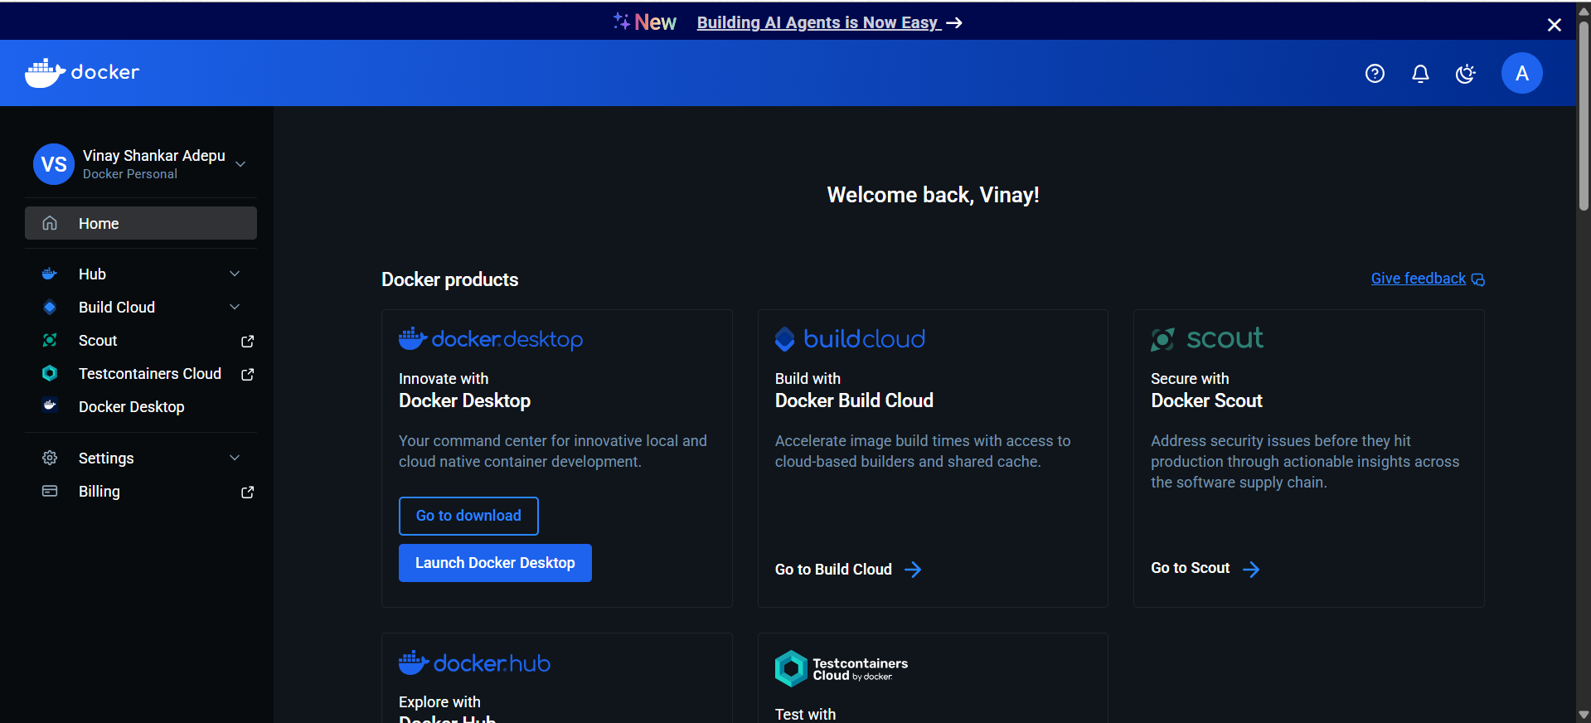

1. Git Hub

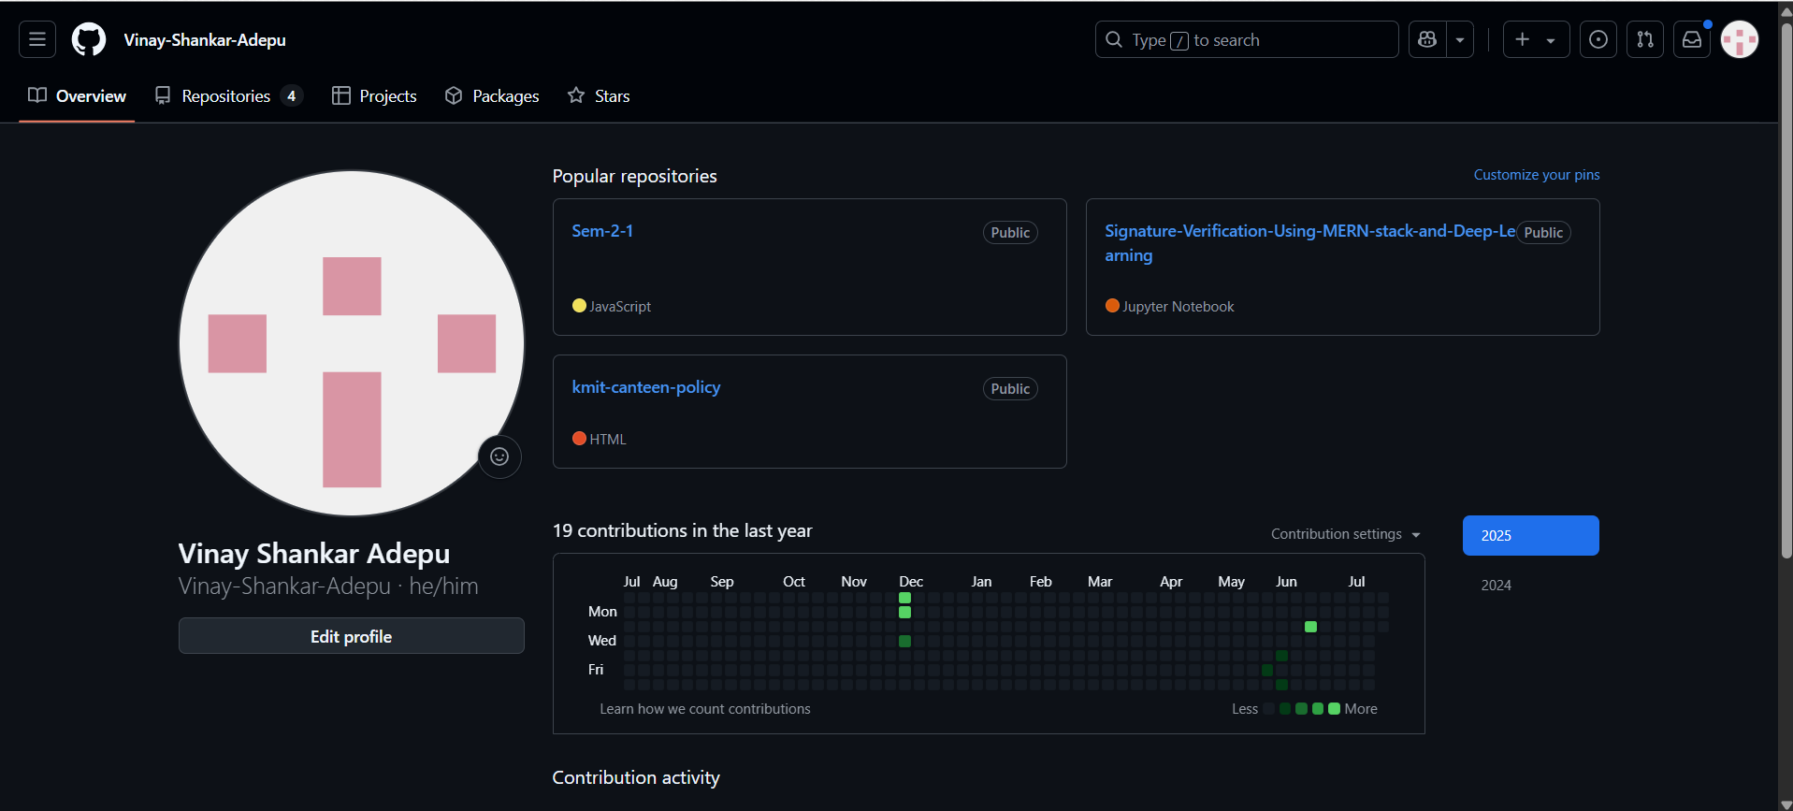

1. Checking Version Controls

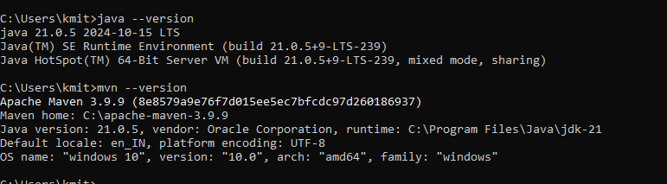

1. Tom Cat

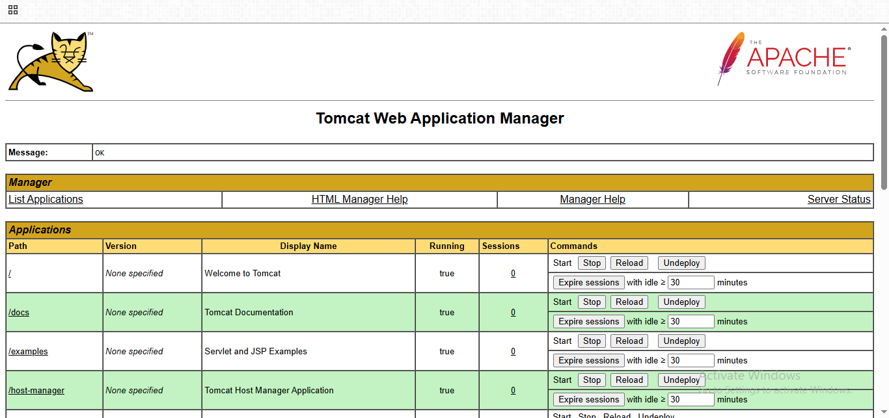

**Abstract Writing:**

Spotify is a popular app that allows people to listen to millions of songs and podcasts online anytime without needing to download them. It helps users easily find songs, create and share playlists, and receive personalized music suggestions based on their mood. The app streams music directly over the internet, using advanced computer programs designed to support many users simultaneously without issues. Studying Spotify in software engineering is valuable because it demonstrates how software can be built to handle large user bases, deliver customized content, and provide fast, seamless access to music. Overall, Spotify combines smart technology with a simple design to make enjoying music easy and accessible anywhere.